“Product Optimization & Revenue Contribution Analysis for Afficionado Coffee Roasters”

INDEX
Sr. No. | Content | Page No.
 | Chapter 1: Project Overview | 1&2
1.1 | Project Title | 1
1.2 | Introduction | 1
1.3 | Objective | 1
1.4 | Stakeholder | 2
 | Chapter 2: Data Description | 3 & 4
2.1 | Data Description | 3
2.2 | Data Preprocessing | 4
 | Chapter 3: Methodology | 5 & 6
3.1 | tools and Technology Used | 5
3.2 | Analytical Approach | 5
 | Chapter 4: Interface | 7 & 8
4.1 | Dashboard Features | 7
4.2 | KPIs | 7
4.3 | Design & Color | 8
 | Chapter 5: Visualization Results | 9 & 11
5.1 | Key Findings | 9
5.2 | Visualization Examples | 9
 | Chapter 6 : Recommendation | 12
6.1 | Recommendation | 12
 | Chapter 7: Future Work | 13
7.1 | Future Improvements | 13
 | Chapter 8: Conclusion | 14
8.1 | Conclusion | 14
8.2 | Reference | 14

Chapter 1: Project Overview
  - project tiltle
“Product Optimization & Revenue Contribution Analysis for Afficionado Coffee Roasters”.

  - Introduction
- Using transaction data, this research examines Afficionado Coffee Roasters' sales performance to determine product demand, revenue distribution, and store-level performance.
- Python for Exploratory Data Analysis (EDA) is used to perform the analysis, and an interactive Streamlit dashboard is used to view the results.
- Key parameters including total revenue, sales volume, top-performing products, and revenue distribution across categories and shop locations can be explored by users of the dashboard.
- This project's goal is to pinpoint significant sales patterns and offer information that will help improve company decision-making.

  - Objective
The main objective of the project:
- To analyze the sales data of Afficionado coffee Roasters to understand overall business performance.
- To identify the top-performing products based on sales volume and revenue.
- To examine the revenue distribution across different product categories and store locations.
- To explore relationships between product popularity and revenue generation.
- To develop an interactive Streamlit dashboard for visualizing key sales metrics and insights.
- To provide data-driven insights that can support better business and marketing decisions.

  - Stakeholder
- Using transaction-level sales data, this project offers a data-driven examination of Afficionado Coffee Roasters' sales performance. The project's primary goal is to assist stakeholders in comprehending how various items, categories, and retail locations affect overall firm revenue.
- The project seeks to give a better understanding of product demand, revenue generation, and sales distribution within the company by examining important sales data and trends.
- Decision-makers may now readily access and comprehend the analysis thanks to an interactive dashboard created with Streamlit. Revenue share by product category, total revenue, total product sales volume, and other crucial business KPIs are all shown on the dashboard.
- Additionally, it features visualizations that showcase the best-performing products according to revenue distribution throughout product categories, sales volume and revenue, and shop location performance.
- Stakeholders can apply filters on the dashboard, such as product type, category, and shop location, to dynamically explore the data and concentrate on particular areas of interest.
- Finding trends, comparing performance across various divisions, and deriving insightful conclusions from the sales data are all made simpler by this interactive approach.
- In general, the initiative facilitates data-driven decision-making by offering lucid insights into revenue trends and product performance. Stakeholders can use the results to optimize inventory management, develop better product strategies, and find ways to increase sales performance at various shop locations.

Chapter 2: Data Description
2.1 Dataset Description
The Afficionado Coffee Roaster dataset have a Transaction sheet of each products. There are 12 columns in the dataset including the Revenue column which is created for the purpose to get the overall revenue getting from the product. Small description of each column as follows:
Column | Description
transaction_id | A unique identifier assigned to each sales transaction.
Year | The yearin which the transation took place(i.e. 2025)
transaction_time | The time of the day when the transaction occurred.
transaction_qty | The number of units of a product sold in a particular transaction.
Store_id | A unique identifier assigned to each store location.
store_location | The physical location or branch where the product was sold.
product_id | A unique identifier assigned to each product sold by the store.
unit_price | The price of a single unit of the product sold.
product_category | The broad category to which the product belongs, such as coffee, tea, or bakery items.
product _type | A more specific classification of the product within a category.
product_detail | The detailed name or description of the product that is sold.
Revenue | calculated column, to get total income generated from the sale of a product, calculated based on the quantity sold and the product price.

2.2 Data Preparation
- In order to prepare the raw dataset for insightful analysis and visualization, data preparation is a crucial stage in the data analysis process. To make sure the data in this project was clean, organized, and appropriate for producing insights, a number of preparation procedures were carried out.
- The Pandas package was used to load the dataset into Python, where it was then analyzed to determine its variables and structure.
- To confirm the data types of the columns and make sure the dataset could be used efficiently for analysis, basic checks were carried out.
- To calculate the overall sales value produced from each transaction, a new feature called Revenue was developed. The transaction quantity and the product's unit price were multiplied to determine this column.
- The creation of this column facilitated the analysis of revenue-related variables, including store performance, overall revenue, and revenue distribution across categories.
- Following preprocessing, the cleaned dataset was used to create the interactive Streamlit dashboard for displaying important sales insights and for exploratory data research.
- Missing values were identified and removed from the dataset in order to improve data quality. It is incorrect to deal with missing value rows directly because doing so increases data loss.
- We can use the arithmetic value (Mean, Median, Mode) to replace the missing number rather than deleting it. As a result, mistakes during analysis and visualization were prevented.
- There are various situations in which the Arithematic values are used. If the column values are numerical, we can substitute the mean or median for any missing values; for categorical values, we can use the mode.

Chapter 3: Methodology
3.1 Tools and Technologies used
The following tools and technologies were used to complete this project:
CSV Dataset (Excel): The sales data is stored in excel csv format and used as a peimary data source for the analysis.
Python: Python was used as the main programming language for data analysis. Data preprocessing and building the dashboard.
Pandas: pandas library is used for data manipulation, data cleaning, grouping and performing calculations on the dataset.
Matplotlib: matplotlib is another library used to create visualization such as bar charts anf scatter plots to analyse sales trends.
Seaborn: seaborn, a library used to enhance the visual appearance of the charts and support data visualization.
Streamlit: streamlit is a library in python used to build an interactive dashboard tha allows users to explore the sales data usig filters and visualizations.
Visual Studio Code(VS Code): VS code used as the development environment for writing and running the python and streamlit code.

3.2 Analytical approach (EDA)
- An exploratory data analysis (EDA) approach was employed to comprehend Afficionado Coffee Roasters' performance and sales trends. Before making judgments, EDA assisted in finding correlations, trends, and patterns in the dataset. Python packages like Pandas, Matplotlib, and Seaborn were used to do the analysis.
- To better examine the data, a number of visualizations were made. Bar charts were utilized to determine the best-performing products based on income and sales volume, making it easier to see which products are most important to the company. The income distribution across product categories was examined using a different graphic, which made it easier to determine which categories were making the most money.
- By contrasting the revenue produced by various products, the analysis also looked at store-level performance. In order to better understand how product demand affects total revenue, a scatter plot was also employed to examine the link between product popularity (sales volume) and revenue creation.
- More visualizations are used for finding least product contribute to the total revenue. Revenue shared by category, type of product.
- Filters were added to the dashboard to make the analysis more interactive and user-friendly. These filters make it simpler to examine particular dataset segments and obtain deeper insights by enabling users to study the data according to product category, product type, and retail location.
- All things considered, the EDA method assisted in locating important sales trends and performance metrics that promote a deeper comprehension of the company's operations and revenue patterns.

Chapter 4: Interface
4.1 Dashboard Feature
- The dynamic representation of coffee shop sales data offered by the Streamlit dashboard makes it simple for users to comprehend business success. Key Performance Indicators (KPIs) including Total Revenue, Total revenue, Total Quantity Sold, and Number of Stores are displayed on the dashboard and provide a brief overview of overall sales activity. Apart from the KPI data, the dashboard has other visual charts to show insights.
- These include Revenue Contribution by Product Category to determine which categories bring in the most money, Revenue by Product Type to compare sales performance across various product kinds, and Top Selling Products and total quantity sold charts to illustrate product popularity. Revenue by store location to know about which store is generating more revenue. In order to demonstrate how products perform in terms of both quantity sold and revenue earned, the dashboard additionally displays a Product Performance Comparison (Volume vs. Revenue) using scatter plot. Additionally, Revenue Share visualizations make it easier to see how various categories and products affect overall revenue.
- Users can choose particular years, retail locations, product categories, and product kinds using the filter options in the sidebar, which makes the dashboard more dynamic. Based on the chosen filters, the dashboard automatically refreshes all data and visualizations. Users may readily examine the sales statistics and obtain insightful information from the dashboard thanks to its dynamic design.

4.2 KPIS
- Total Revenue: The total sales revenue from every transaction in the dataset is displayed by this KPI. It is computed by adding the revenue from all transactions and multiplying the quantity of goods sold by their unit price. It offers a comprehensive assessment of the company's financial performance.
- Product Sales Volume: This measure shows how many products were sold overall over the chosen time frame. It helps determine the total demand for goods and is computed by adding the transaction_qty values.
- Category Revenue Share: This KPI shows the portion of overall revenue that a certain product category contributes. It assists in determining which product categories account for the greatest share of sales and total revenue.
- Revenue Concentration Ratio: This measure indicates the proportion of total revenue that comes from the best-performing goods. It assists in determining if the company's revenue is spread across numerous goods or concentrated in a small number of important products.
- Product Revenue Contribution: This KPI indicates how much money each product makes in relation to total sales by calculating the average contribution of each product to total revenue.
- Product Efficiency Score: This measure assesses a product's effectiveness by taking into account both revenue creation and sales volume. It assists in identifying goods that are profitable and have strong demand.

  - Color & Design
- To make it easy for users to comprehend the information displayed, the dashboard was created with a simple and eye-catching structure using interactive insight at the top of the dashboard. To fit the context of the coffee shop dataset, a color scheme inspired by warm coffee was applied throughout the dashboard.
- In order to keep a consistent theme relating to the coffee industry, darker hues of brown and coffee colors are utilized for headings, sidebars, and borders. The main background's light beige tone produces a soft and comfortable browsing experience.
- This color scheme keeps the dashboard visually balanced while giving it a polished, themed look.
- The dashboard was designed with a straightforward and visually appealing framework to facilitate users' comprehension of the information presented. The dashboard's color design was influenced by warm coffee in order to fit the environment of the coffee shop dataset.
- Darker shades of brown and coffee colors are used for headings, sidebars, and borders in order to maintain a consistent theme related to the coffee industry.
- A gentle and browsing experience is created by the light beige tone of the primary background. This color scheme gives the dashboard a clean, thematic appearance while maintaining visual balance.

Chapter 5: Visualization Results
5.1 Key findings
- A number of significant insights on product performance and income distribution are revealed by the dataset analysis. Tea is the second-biggest contributor, indicating considerable consumer demand, while coffee is the highest revenue-generating category, accounting for the largest portion of overall sales.
- A sizeable amount of the total sales comes from drinking chocolate and bakery goods, suggesting that complementing food items are crucial to the company. Additionally, the analysis reveals that a small number of high-performing products account for a sizable portion of total income, indicating that sales are concentrated around a few well-liked products.
- Differences between sales volume and profitability are further highlighted by the fact that some products sell in larger quantities but make relatively less money. Overall, the results show that coffee-based beverages are the most significant goods for the company since they account for the majority of sales and revenue.

5.2 Visualization charts
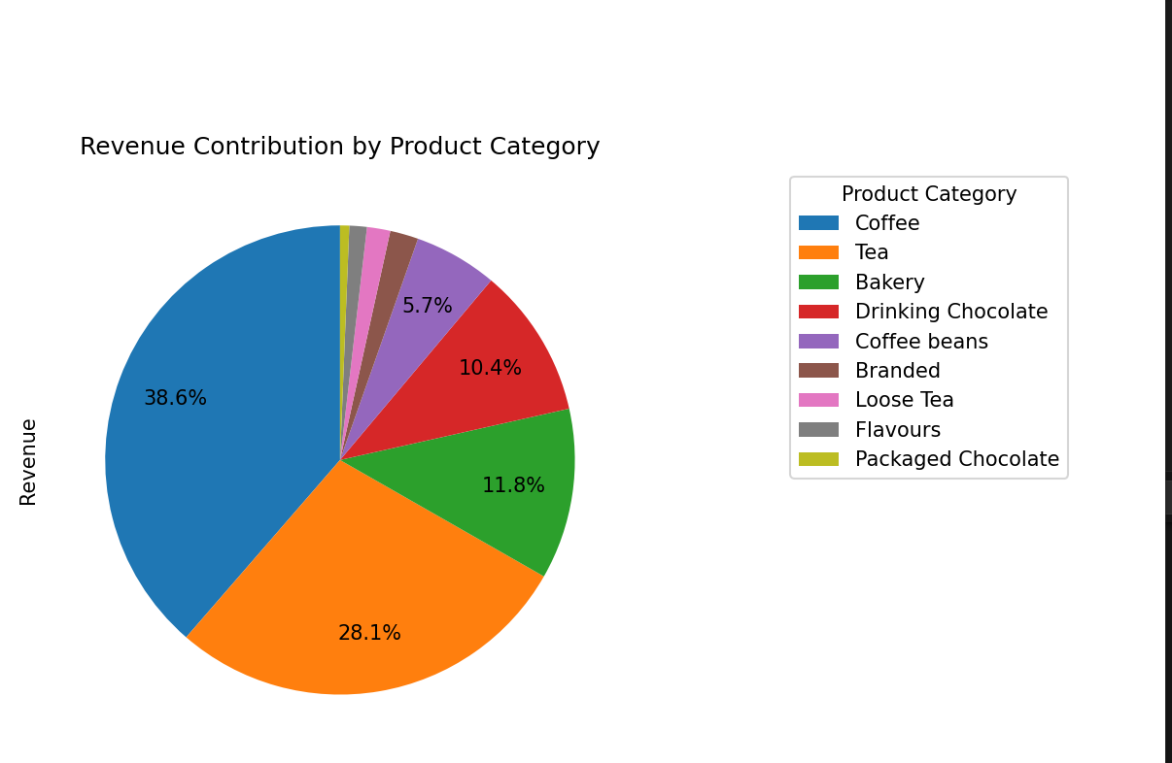
The percentage of total revenue produced by each product category is displayed in the Revenue Contribution by Product Category pie chart. The two most popular and lucrative categories are coffee (38.6%) and tea (28.1%). A substantial portion of revenue is also contributed by drinking chocolate (10.4%) and bakeries (11.8%). Smaller amounts of the total revenue come from other categories such packaged chocolate, coffee beans, branded goods, loose tea, and flavors.
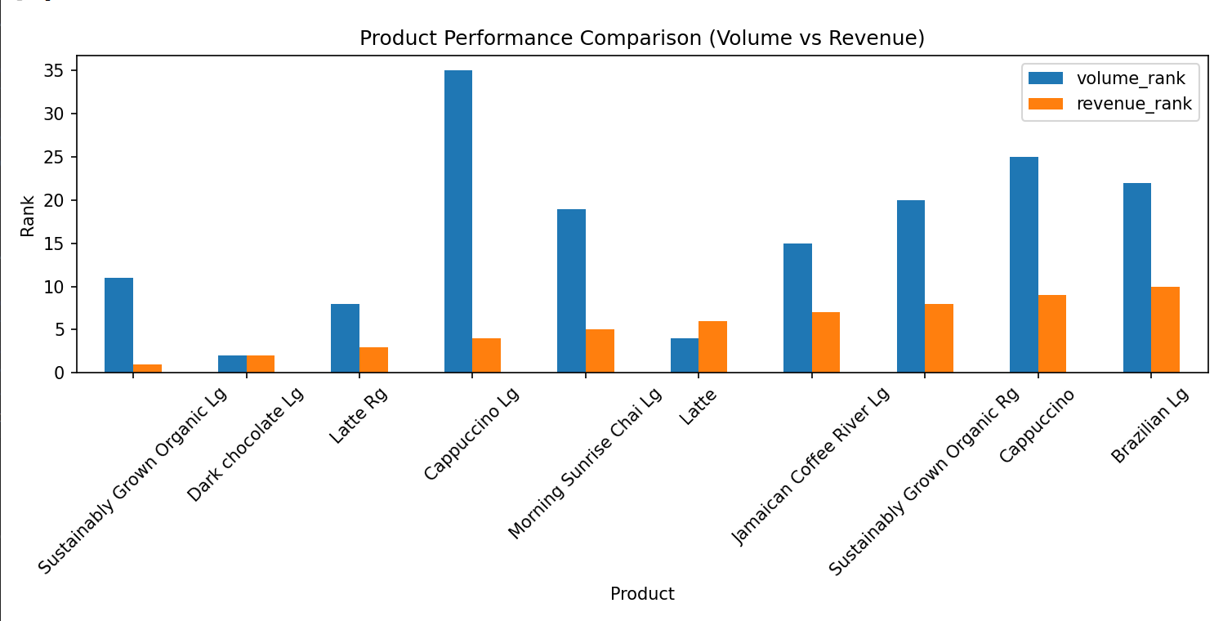
Products are ranked according to sales volume and revenue creation in the Product Performance Comparison (Volume vs. Revenue) chart. It demonstrates how certain products make more money even with lower sales volumes, while others sell in larger quantities yet do not make as much money. For instance, despite variations in volume rank, brands like Brazilian Lg and Cappuccino have significant revenue ranks. This comparison makes it easier to distinguish between very profitable products and those that are just in high demand. In general, the chart facilitates better decisions about product optimization and aids in analyzing product performance.

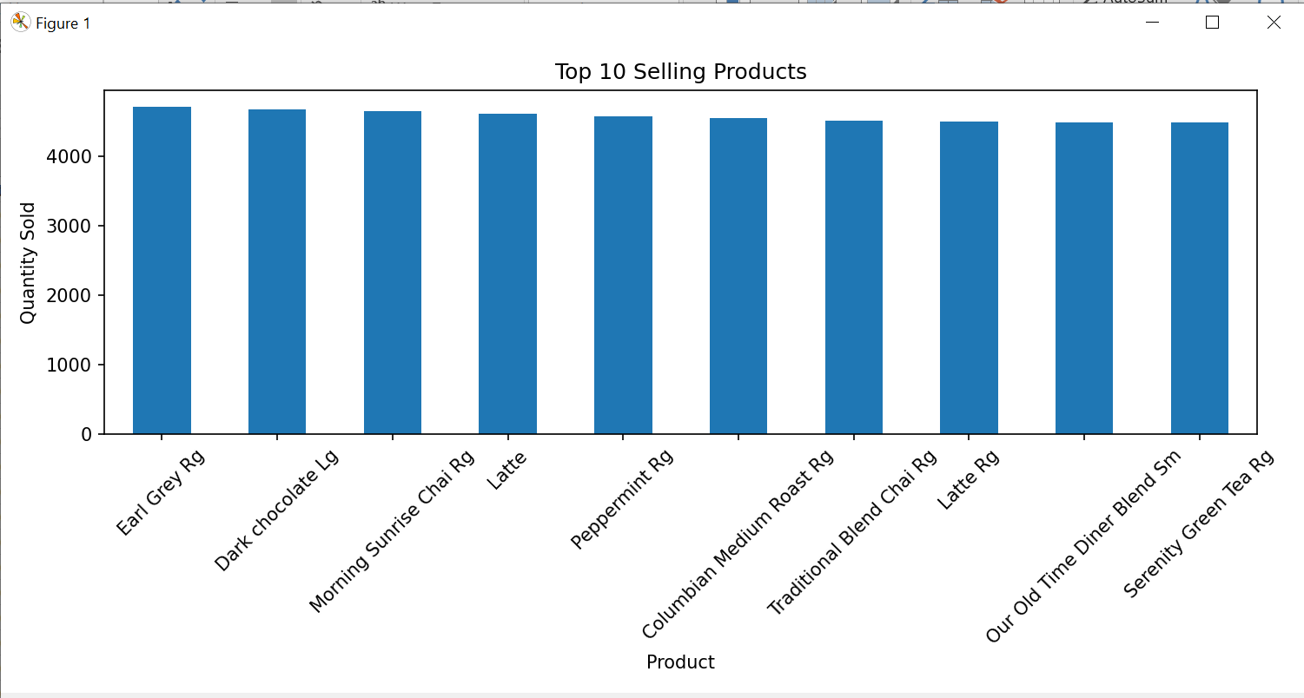
The graph, which shows the top 10 best-selling items according to quantity sold, demonstrates that every item performs at a pretty comparable level, with sales approximately falling between 4,400 and 4,700 units. Earl Grey Rg seems to be the best-selling item among them, however it is only somewhat better than Dark Chocolate Lg, Morning Sunrise Chai Rg, and Latte. The little variations between the bars show that there isn't a single product that dominates the market; rather, demand is split rather evenly among different products. Even the least popular items on the list, such Serenity Green Tea Rg and Our Old Time Diner Blend Sm, continue to have high sales numbers. Overall, the graph points to a well-balanced product line with steady high demand for a number of different things

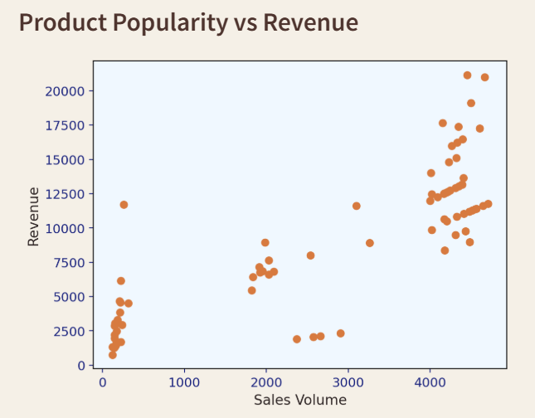
The scatter plot shows a generally positive link between revenue and product popularity as determined by sales volume. The cluster of points on the right side of the image, where high sales volumes (approximately 4,000–4,500 units) correspond to greater revenues (about 10,000–21,000), makes it clear that revenue tends to rise along with sales volume. On the other hand, although there is some fluctuation reflecting differences in pricing or product value, products with lower sales volumes (below 500 units) generate comparatively lower revenue. With a few outliers, the intermediate range (about 1,500–3,000 units) displays moderate revenue, indicating that some products might be more expensive even though they are less popular. Overall, the plot shows that although increased sales often result in increased revenue factors such as pricing and product type also influence the total revenue generated.

Chapter 6: Recommendation
6.1 Recommendation
- A number of suggestions for enhancing company performance can be made in light of the study of the coffee shop sales data. The company should keep concentrating on marketing and growing coffee-based beverages since they are the primary sales drivers and account for the largest portion of income.
- Similar to this, there is a lot of demand for tea items, so adding new types or offering special deals could boost sales in this area.
- Combining complimentary foods and baked goods with beverages through combination deals may boost overall sales because these items account for a moderate portion of revenue.
- Additionally, the study reveals that a small number of products account for a significant amount of overall income, suggesting that marketing, inventory control, and shop displays should give priority to these high-performing products.
- Products with poor sales volume or revenue contribution should also be evaluated to see if they need to be replaced with more popular items, have their prices adjusted, or have greater advertising.
- Furthermore, knowing how sales volume and revenue creation are related might assist the company concentrate on successful and well-liked products.
- By putting these tactics into practice, you may enhance product optimization, boost sales, and facilitate better corporate decision-making.
- If talking about the Revenue by store location so lower Manhattan shop is giving more revenue. As the Volume of product increases,the Revenue is increasing.

Chapter 7: Future Work
7.1. Future Improvement
- Even if the current project offers insightful information on coffee shop sales performance, there are a number of ways to improve the dashboard's functionality and analysis going forward.
- Incorporating time-based information, such as monthly or hourly sales trends, to better understand client purchase behaviors throughout the day or across different seasons is one potential enhancement. This would make it easier for the company to organize inventory and marketing.
- Adding more sophisticated visualizations and predictive analytics, like employing machine learning models to anticipate future sales, could be another upgrade. The company would be able to predict demand and make better strategic choices as a result.
- Adding real-time data sources to the dashboard will also improve it and allow stakeholders to dynamically track sales performance. To enable a more thorough examination of product performance, shop comparisons, and consumer behavior, more interactive elements and sophisticated filters might be included.
- The dashboard would become more potent and helpful for long-term company analysis and decision-making with these enhancements.
- Time-based analysis, such as hourly, weekly, or monthly sales trends, can be added to this project in the future to make it better.
- This would make it easier to comprehend how customers behave while making purchases at different times of the day or in different seasons. Better decision-making in areas like personnel, promotional planning, and inventory management can be aided by this kind of analysis.

Chapter 8: Conclusion
8.1. conclusion
- This project examined Afficionado Coffee Roasters' sales data to comprehend revenue distribution, product performance, and general business trends. To analyze the dataset and find important insights, Python was used for exploratory data analysis (EDA).
- To assess the overall revenue from product sales, a new Revenue column was added. This allowed for the evaluation of the financial performance of various items and categories.
- According to the data, coffee products account for the largest portion of sales, followed by tea and other supplementary goods like sipping chocolate and baked goods.
- The study also revealed that a small number of products account for a significant amount of total revenue, underscoring the significance of these essential products for the success of a business.
- To illustrate the results using KPI metrics and charts, an interactive Streamlit dashboard was created, which makes it simple for users to examine the data using filters.
- Overall, the research shows how data visualization and analysis may assist companies in identifying high-performing items, comprehending sales trends, and facilitating improved decision-making.

8.2 Reference
- The main source of data for analysis in this research was the dataset, which was made available on the project webpage.
- Google was used to find more references in order to comprehend the project specifications, data analysis methodologies, and visualization strategies.
- Learning how to use Python libraries like Pandas, Matplotlib, Seaborn, and Streamlit for data processing and dashboard development was made easier by online resources.
- In order to comprehend the basic ideas of data analysis, data cleansing, and visualization, degree textbooks and study materials were also consulted.
- These references made it possible to guarantee that the project was finished with accurate processes and appropriate analytical approaches.

